# **Team 3 Penetration Testing Report**

**Allie Evan, Pete Howe, Haris Rahid, Simon Wake**

**Executive Summary**

Over the past three weeks, we carried out a penetration test on a duplicate version of your server Humbleify. The duplicate version was used to prevent crashing the server, but the duplicate operated in the exact same way as the live website. The only information that my team was given was the IP address of your server. With this IP address, we were able to find out the usernames and passwords of all seven employees as well as the email addresses, credit card numbers, social security numbers, and first and last names of all 430,000 of your customers. This should be very alarming because of the damage that a malicious hacker could do if they exploited your server in the same way that we did. A malicious hacker could use this data to harm your company as well as your customers. In addition to the previously mentioned information, we were also able to discover an encrypted message from one of your employees to someone outside of the organization describing a “backdoor” into your server. This would allow the employee to access the server, and the sensitive information on the server, even if that employee was terminated and their account was removed from the system. It is highly suspicious that a current employee would do this because it can be reasonably assumed that they would have used this “backdoor” to harm your company if they were fired. We also discovered notes that employees have left for themselves describing how to access certain information and databases. All of this information could be used against your company, Humbleify, if the data were to get into the wrong hands.

Your server was exploited by using different hacking techniques. These techniques were very effective due to the weak security measures that your company had in place. The names and company email addresses of all employees were in plain sight on the website. This in itself is not a bad practice if you would like your customers to be able to contact your employees. However, with this information, we were able to guess the username of each employee and use a password cracking method to login to the employee portals. The passwords of your employees were very weak allowing us to crack the passwords in minutes. We recommend that the passwords of your employees should be a four word passphrase. Another bad security practice was allowing each employee to have access to the database that contained sensitive customer information. By doing this, a hacker only has to gain access to one employee's account to be able to access the database. We recommend only allowing a few high ranking and trustworthy employees access to customer information. Regarding the website as a whole, the servers that make the site run have too many access points for malicious hackers and should be updated to have better security.

# 

# **1. Project Scope Description**

## **1.1. Objectives**

We have entered into a contractual agreement with Humbleify for us to carry out a vulnerability assessment of a specific Humbleify asset hosted on vagrantcloud at deargle/pentest-humbleify.

The agreed-upon objectives are threefold:

1. Document vulnerabilities that you are able to successfully exploit on the server. Describe in detail what you did and what level of access you were able to obtain. If you obtain a user account with limited privileges, document whether you were able to escalate the privileges to root. Document each exploit that you are able to successfully launch.
2. Document potentially sensitive information that you are able to obtain from the server. These could include user files or web, database, or other server files.
3. For both 1 and 2 above, argue for methods that could protect the vulnerabilities and sensitive information from > exploitation.

## **1.2. Authorization**

We are operating under the following authorization:

You are hereby authorized to perform the agreed-upon vulnerability assessment of the Humbleify vagrantbox virtual machine with IP address 192.168.56.200. Your scope of engagement is exclusively limited to the single Humbleify asset.

You may:

* Access the server through any technological means available.
* Carry out activities that may crash the server.

You may not:

* Social engineer any Humbleify employees.
* Sabotage the work of any other consultancy team hired by Humbleify.
* Disclose to any other party any information discovered on the asset.

Furthermore, note the following:

* This is a vagrant box development version of a live asset. The vagrant-standard privileged user vagrant is present on this virtual machine, but not on the live version of the asset. Therefore, any access via the vagrant user is moot and out of scope.

# **2. Target of Assessment**

**Table – Server Description**

|  |  |
| --- | --- |
| **Key** | **Value** |
| **Operating System** | **Linux Kernel 3.13 on Ubuntu 14.04** |
| **MAC Address** | **52:54:00:BE:F6:67 (QEMU virtual NIC)** |
| **User accounts** | **tyler**  **bcurtis**  **bschneider**  **cincinnatus**  **jcochran**  **mhayes**  **mzimm** |
| **Services running** | **FTP Version: ProFTPD 1.3.5**  **ssh Version: OpenSSH 6.6.1p1 Ubuntu 2ubuntu2.10 (Ubuntu Linux; protocol 2.0)**  **Http Version: Apache httpd 2.4.7 ((Ubuntu))**  **Rpcbind version: 2-4 (RPC #10000)**  **Ingreslock Version: unknown**  **Mysql Version: MySQL (unauthorized)**  **Irc Version: UnrealIRCd** |
| **Noteworthy Installed Applications** | **MySQL**  **UnrealIRC**  **ProFTPD** |
| **Web sites hosted** | [**http://192.168.56.200/**](http://192.168.56.200/) |
| **Databases, and stored information** | **MySQL database**   * **Contained sensitive customer information including first and last names, email addresses, social security numbers, hashed passwords, and credit card numbers with their expiration date and year** * **Contained employee usernames and passwords stored in plaintext as well as employee salary information** |

# **3. Relevant Findings**

|  |  |  |
| --- | --- | --- |
| **User** | **Password** | **Cross-References** |
| **3.1**  tyler  bcurtis  bschneider  cincinnatus  jcochran  mhayes  mzimm  MySQL root | humbl3ifytyl3r  motocross4life  humblhumbl  hellohello04  jcochran  seyahm  ChangeMe  yfielbmuh | 4.4, 5.4 |
|  |  |  |

**Table – Other Sensitive Information Obtained**

|  |  |  |
| --- | --- | --- |
| **Name** | **Description** | **Cross-references** |
| **3.2** Customer Personal Identifiable Information | SQL database containing sensitive employee and customer information. Customer information includes first and last names, email addresses, SSNs, credit card information stored in plaintext | 4.2, 5.2 |
| **3.3** Root Access | Executable file named “documents.zip” which, when run, gives the user root privileges. Can be run by any user | 4.3, 5.3 |
| **3.4** Personal Notes | Employee personal notes and memos that described how to access MySQL table as well as describing potential vulnerabilities in the server | 4.7, 5.8 |
| **3.5** Employee Emails | Email describing that user “mhayes” can run the command  “sudo cat-shadow” to obtain a list of hashed employee passwords. Other emails from user “bcurtis” to an external user describing a backdoor as well as a method for escalating user privileges | 4.8, 5.9 |
|  |  |  |

**Table – Vulnerable Services**

|  |  |  |
| --- | --- | --- |
| **Service** | **Description** | **Cross-references** |
| **3.6** ProFTPD | The server is running a ProFTPD application. It is using the updated version 1.3.5, which is vulnerable through its mod_copy module that allows unauthorized users access to the SITE CPFR and CITE CPTO commands. The information obtained due to this vulnerability is discussed in section X.C. This dilemma can be mediated by updating ProFTPD to 1.3.6rc1 or newer | 4.6, 5.7 |
| **3.7** WebDAV | WebDAV is enabled for the /uploads/ folder and allows users to remotely connect to the server and upload documents. An attacker can upload malicious documents that may enable them to gain access to the server and allow for lateral movement. WebDAV should be disabled when not in use and uploads of specific file types like .php should be limited. | 4.9, 5.10 |
| **3.8** Ingreslock | This service can be used to limit access to SQL databases, but it also automatically creates a backdoor when connecting to port 1524, which can be configured to login as a specific user without needing to enter a password. | 4.10, 5.11 |
| **3.9** UnrealIRCD | The server is running version 3.2.8.1, which has a backdoor exploit that can be used to gain access to the server as Tyler. This can be remedied by upgrading to UnrealIRCD 6.0.7. Alternatively, if this service is not regularly used, it should be shut down. | 4.5, 5.5 |
|  |  |  |

# **4. Supporting Details**

**4.1 MySQL**

Through an nmap scan of the server we discover MySQL running on port 3306 session 7.1 to view the scan. We performed this exploit by:

1. To access the database we used a message discovered through the exploit of FTP (see section 4.7) written by Tyler. The message describes how to connect to the Humbleify MySQL database, password hints, and the salt as well as hash for mySQL root. See section 7.6 for the exact message. 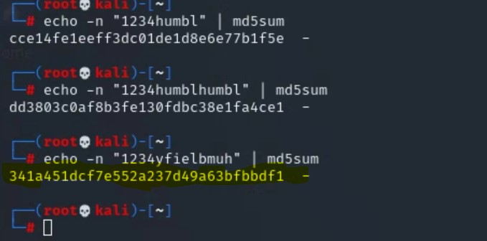
2. Using the password hint of “company website” we were able to guess and check different passwords using the echo command with the md5sum hash as shown below. After a few tries we were able to guess the correct password that replicated the MySQL hash in Tyler’s message.

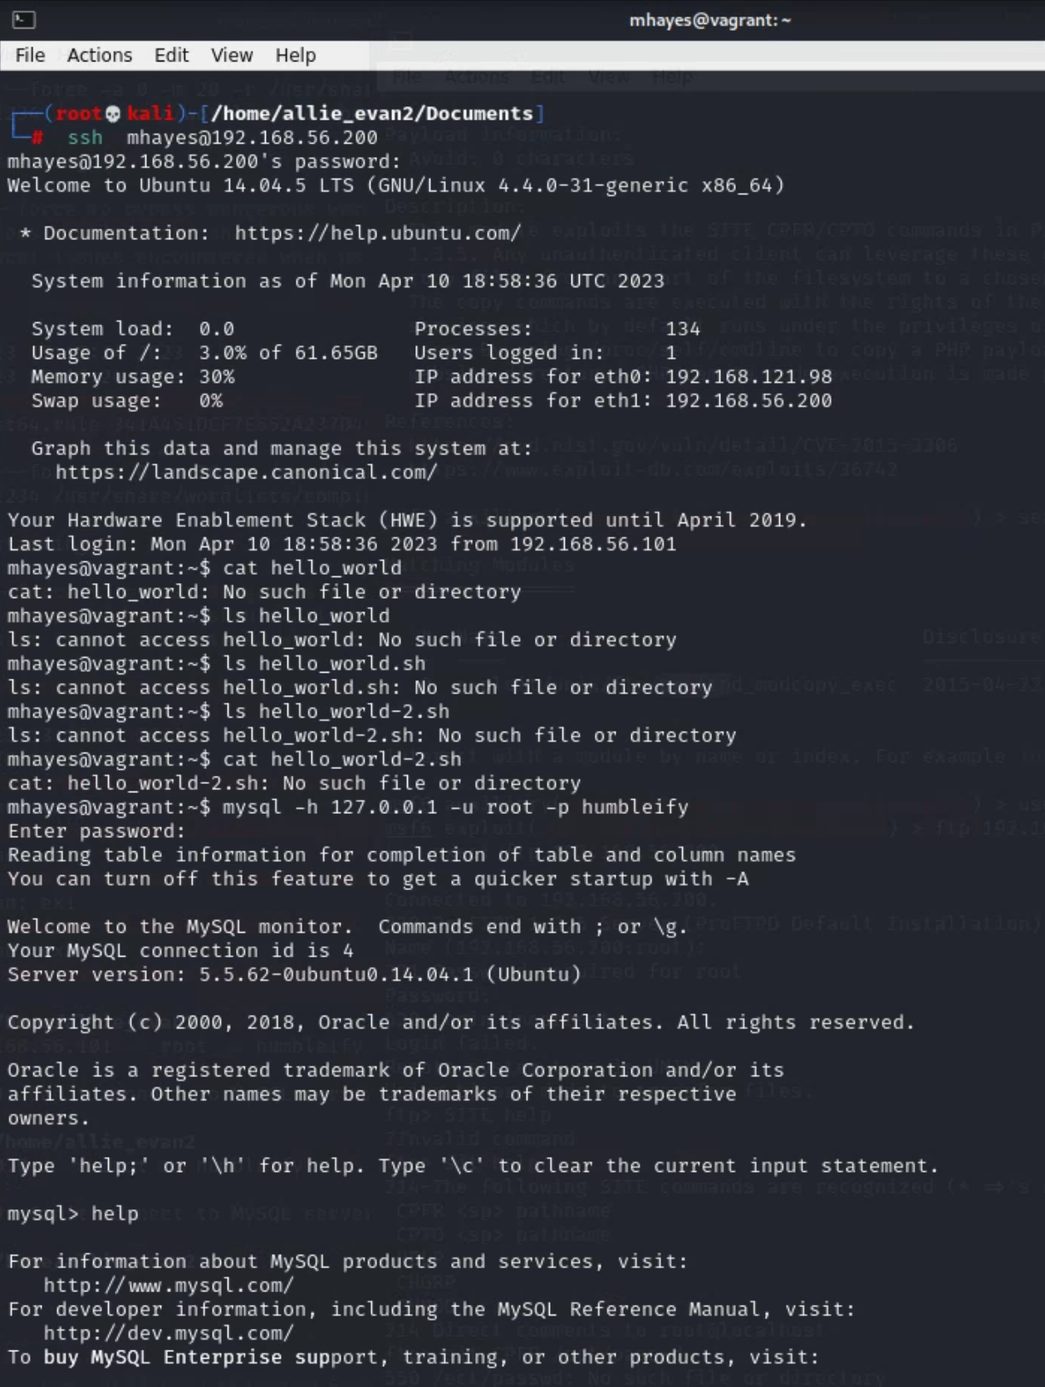

1. With the password we discovered, and access command provided by Tyler’s note we were able to successfully enter the MySQL database when logged into Humbleify’s server.
2. Using the commands provided by Tyler’s note we navigated through the database and uncovered personal identifying customer information, employee passwords, and employee salaries. See sections 7.12 and 7.14 for more information found in the database

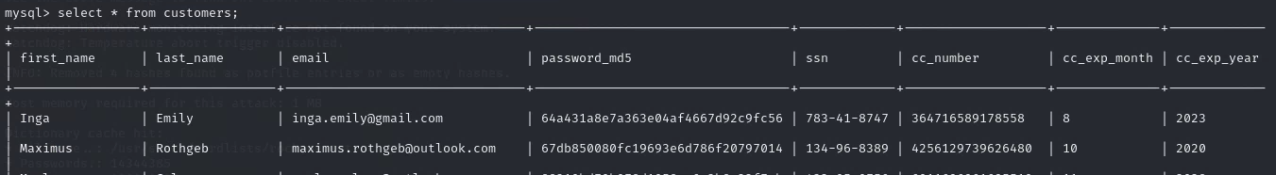

**4.2 Customer Personal Identifiable Information**

We discovered a vulnerability to the MySQL database through an nmap scan. See section 7.1.

1. We gained access to the MySQL database as described in section 4.1.
2. We were able to navigate through the database from directions in a personal note. See sections 4.7 and 7.6.

The below information was found in the database. See section 7.12 for the table format.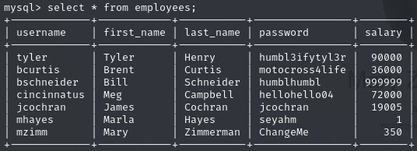



**4.3 Root Access**

We were able to escalate to root in several ways:

The first way we achieved root access was by logging into Humbleify’s server as Tyler. Tyler has sudo privileges, so by running “sudo -s” a root shell is created. 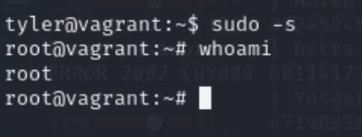

The second way we achieved root privileges was by running “/home/bcurtis/recycle-bin/documents.zip” which gives any user root access (see section 7.15).

**4.4 Passwords**

We performed this exploit by:

1. Guessing the usernames of the employees as first initial of first name plus last name. Usernames were ultimately the same as the local part of email addresses.
2. Next we used hydra to brute force our way into as many users as possible. The hydra command used is shown below.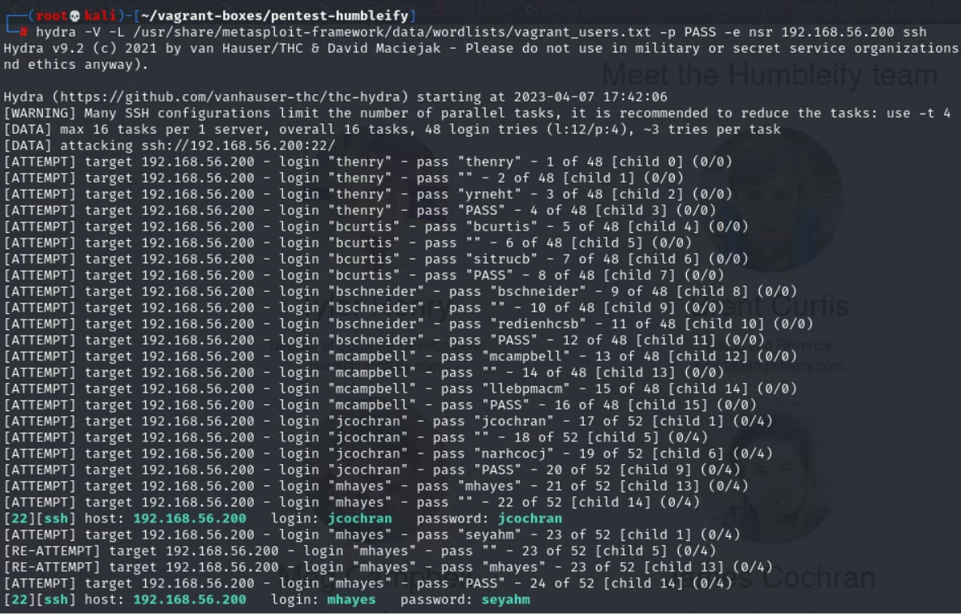
3. These two users gave us enough access to the server to perform sufficient reconnaissance to be able to further exploit the server (see sections 4.7 and 4.8).
4. Additional user password hashes were gained through access to the /etc/shadow file that mhayes has permission to access (see section 4.8.2).

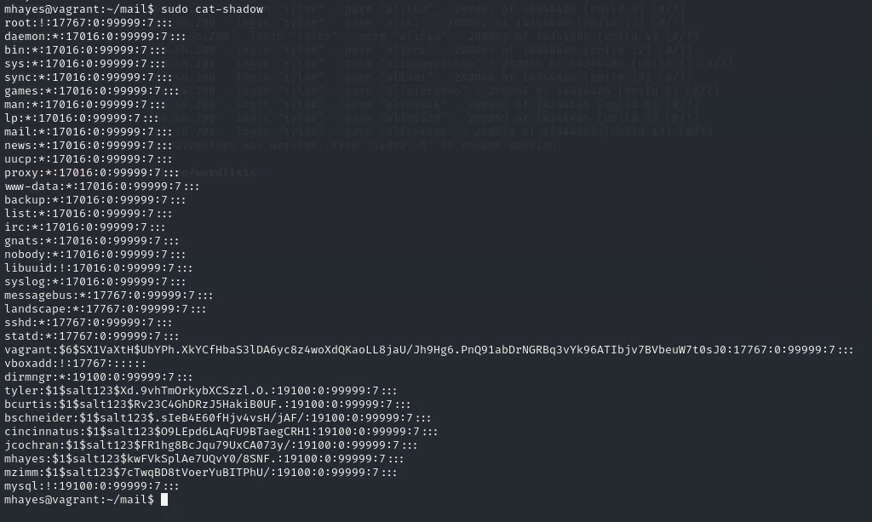

1. These passwords were cracked offline using hashcat (see section 7.17), which gave us access to a total of 5 user accounts when combined with the credentials obtained using hydra.

**4.5 UnrealIRCD Backdoor**

We discovered this vulnerability when we noticed that UnrealIRCd was running on port 6667 using an Nmap scan. We performed this exploit by:

1. Running hexchat
2. Connecting to the IRC service on 192.168.56.200 on port 6667
3. Getting version information after connection

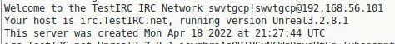

1. Searching version information in metasploit

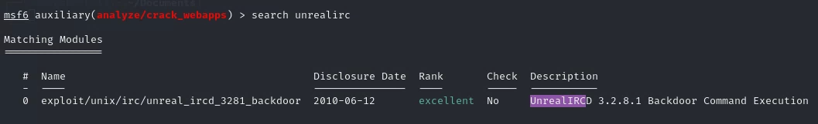

1. Selecting an appropriate payload, and running the exploit

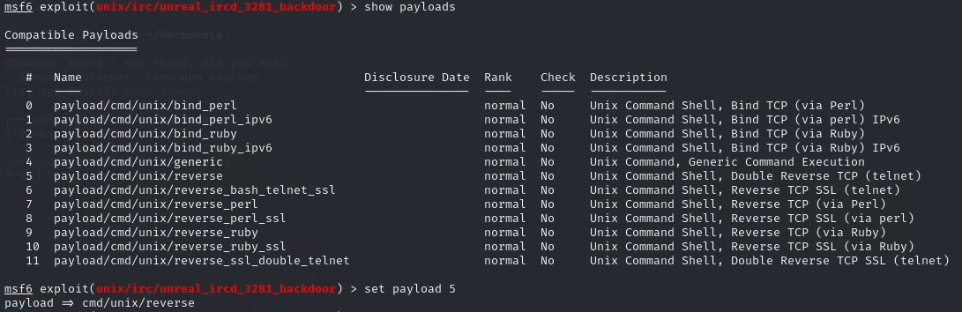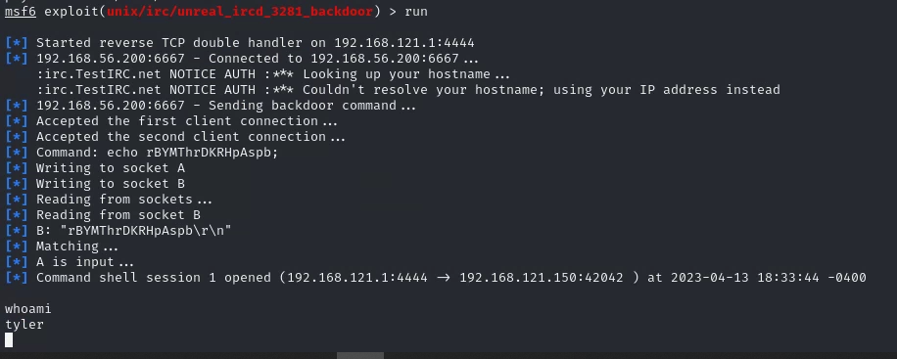

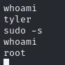

1. Because Tyler has sudo privileges, this can be easily escalated to root.

**4.6 ProFTPD**

This vulnerability was discovered by first running an nmap scan to view the ports open on the network. The scan showed several open ports including TCP port 22 running ProFTPD version 1.3.5 see section 7.1

We exploited this service by:

1. Opening metasploit console to search for possible exploits of ProFTPD version 1.3.5

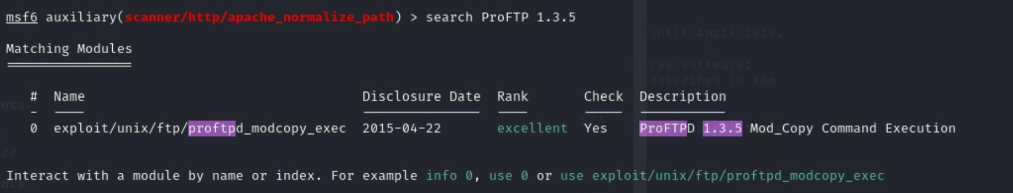

The result returned one exploit matching this service and version. This module exploits the SITE CPFR/CPTO commands in ProFTPD version 1.3.5. Any unauthenticated client can leverage these commands to copy files from any part of the filesystem to a chosen destination. See section 7.2 for a further description of the module used.

1. From the information provided by the exploit description, next a connection to the FTP of the server was established. No credentials were needed to access the module.

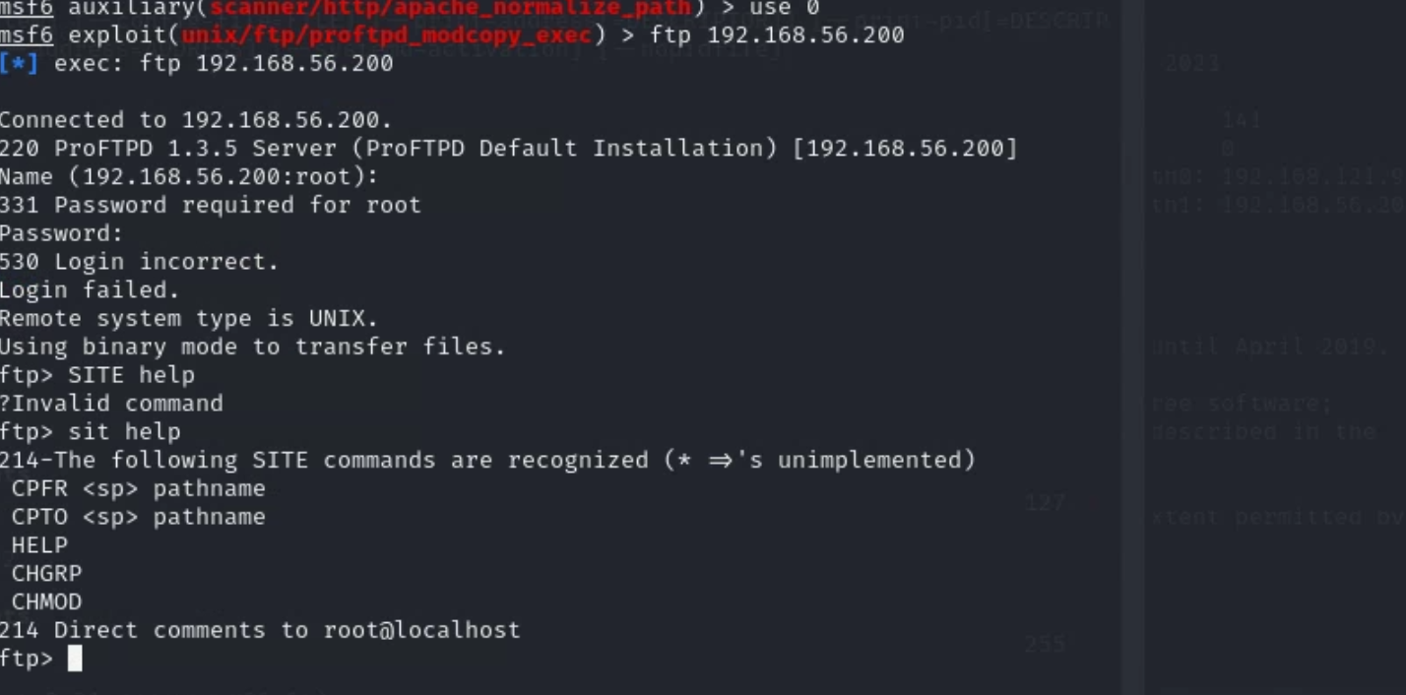

3. The CPFR and CPTO commands were used to copy and paste /ect/passwd file to <http://192.168.56.200/myfile>. This site then displayed all of the usernames in the server.

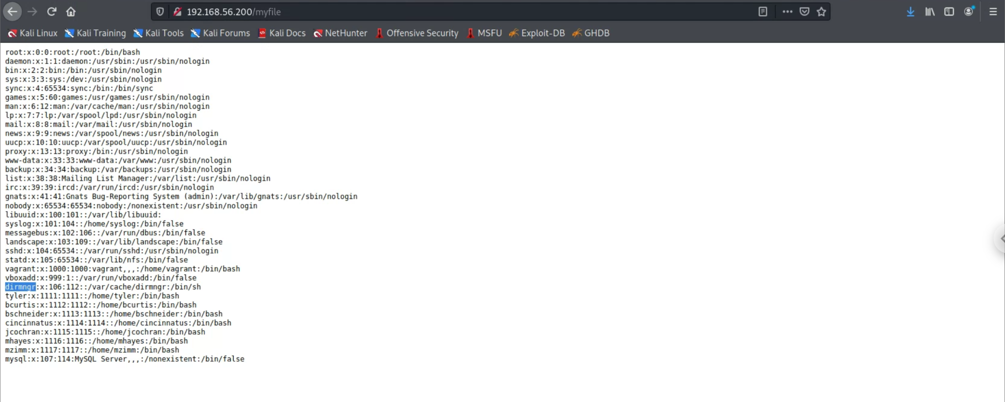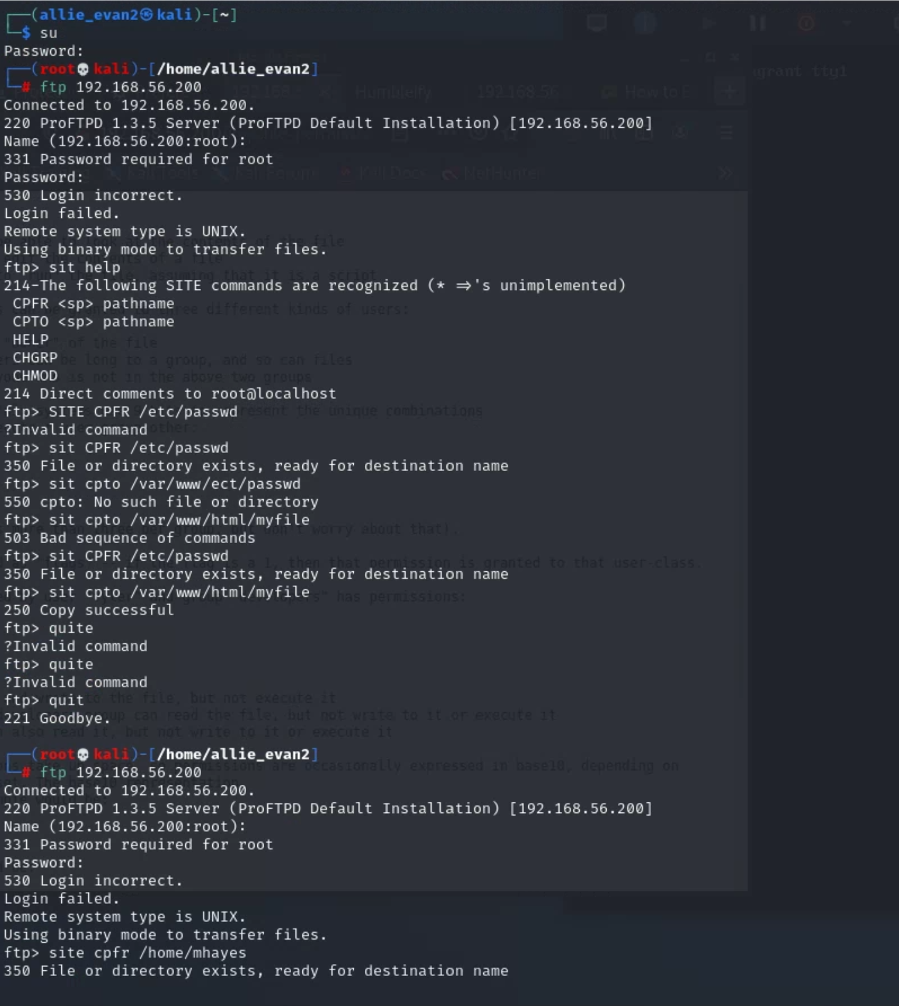

4. Next the files associated with each user login from [192.168.56.200/myfile](http://192.168.56.200/myfile) were copied and pasted to the site [192.168.56.200/imp](http://192.168.56.200/myfile). 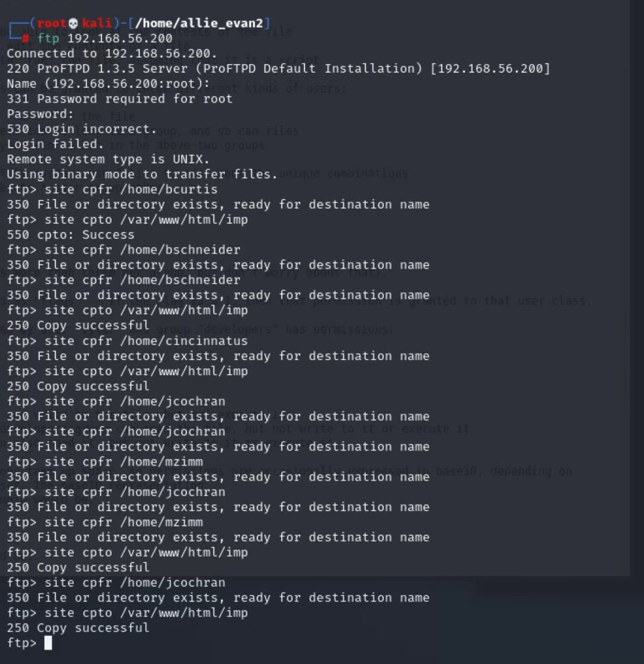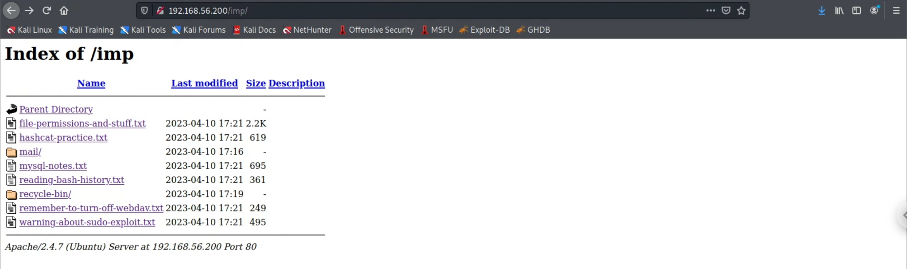

From this exploit we were able to gain access to the ftp service without any credentials, export users’ files, and export the command files running on the server (see section 7.8). Several messages from employees were discovered describing how to access the mySQL database, vulnerable WebDAV on the webserver, who has the ability to use sudo to `cat` a file, and in depth descriptions of the three file and directory permissions. See sections 7.3-7.7 for screenshots of the messages.

**4.7 Personal Notes**

Numerous memos and personal notes were discovered in users’ directories after gaining access to the server using user credentials and the ProFTPD exploit (see section 4.6). While these notes were not vulnerabilities in themselves, they provided important information about other vulnerabilities on the server and were essential for reconnaissance and information gathering.

1. We accessed users accounts after using hydra to obtain passwords (see section 4.4.2).
2. We logged in as jcochran using ssh to remotely access the server

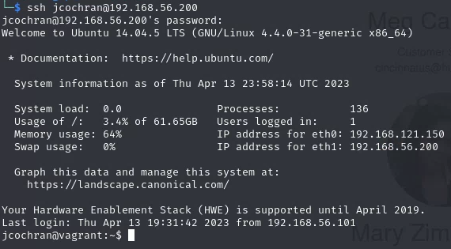

1. Once we had user access to the server, we were able to explore the file directory



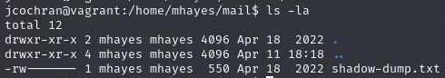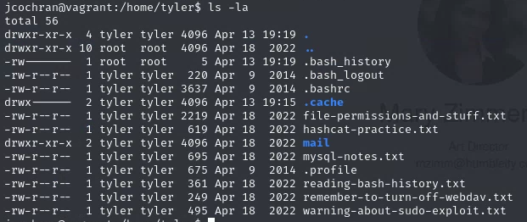

1. While some users restricted access to personal files, others had files that were readable by any user. This allowed us to gain more information about the server, the services running on it, and potential vulnerabilities (see sections 7.3, 7.4, 7.5, 7.6, 7.7, 7.13).

**4.8 Employee Emails**

1. During reconnaissance with the jcochran user account, we discovered email logs in the mail folders of mhayes and bcurtis that had restricted read access (see section 4.7.3).
2. After logging in with mhayes using a password obtained via hydra (see section 4.4.2), we were able to read her email and discovered that mhayes had permissions to obtain password hashes for all other users.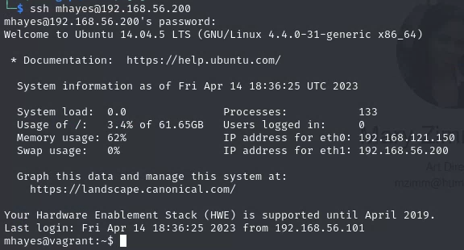

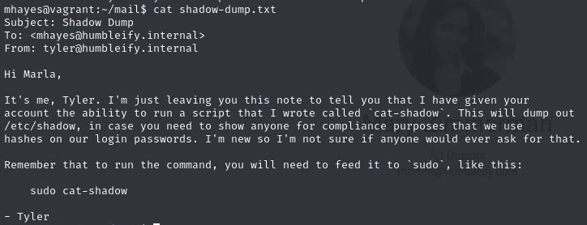

1. These passwords were cracked using hashcat (see section 7.17) to obtain more employee credentials, including bcurtis. Logging in as bcurtis allowed access to more email files similar to above.

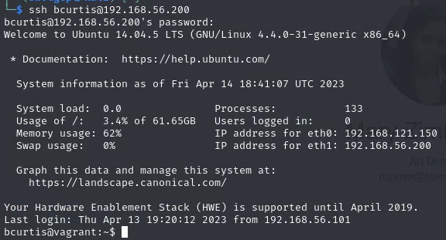

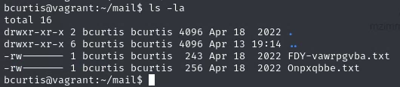

1. While these files were enciphered, it was relatively easy to to break the cipher thanks to other documents in bcurtis’ directory (see sections 7.9, 7.10, and 7.11).
2. The decoded plaintext reveals that bcurtis had a secret way into the server on port 1524, which we know to be the ingreslock backdoor as well as a file called documents.zip, which is an executable file that can be run by any user(see sections 7.11 and 7.15).

**4.9 WebDAV**

We discovered this vulnerability through a clue on a personal note. See section 7.13.

1. We checked if WebDAV is enabled on multiple paths including /uploads/.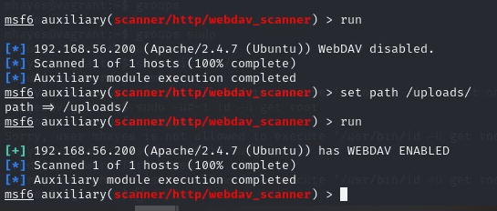
2. Run a davtest for the specific url for uploads. See section 7.16.
3. Upload a file to the server that creates a shell on the local machine when the file is accessed.

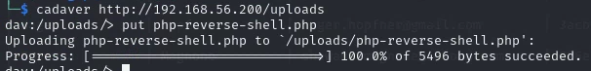

1. Create a shell as shown below.

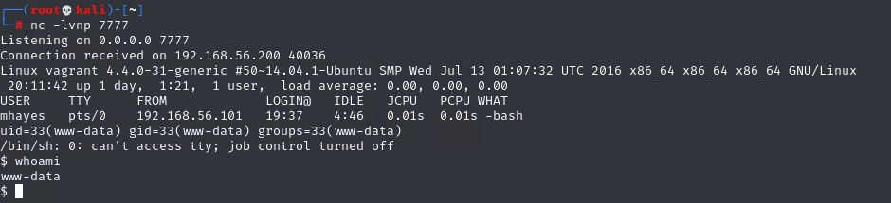

**4.10 IngresLock**

We discovered this vulnerability from an nmap scan that showed Ingreslock running on port 1524 (see section 7.1)

1. While doing reconnaissance we discovered a note that described a backdoor user bcurtis had made on port 1524. See sections 7.10 and 7.11.
2. We then executed the telnet command to connect to port 1524, which logged us in as user bcurtis without any need to authenticate.

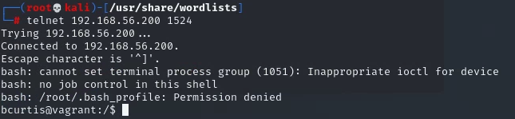

# 

# 

# 

# **5. Vulnerability Remediation**

**5.1 MySQL**

MySQL database should only be accessible by certain users. The password to enter the database also needs to be strengthened. We recommend using a four word passphrase to access the database. See sections 3.7, 4.1.

**5.2 Customer Personal Identifiable Information**

The MySQL database contained the customer personal identifiable information and should be protected better (see section 5.1). Within the database, the SSN, email address, and credit card information should be hashed using the SHA - 256 algorithm. See sections 3.2 and 4.2.

**5.3 Root Access**

Remove executable files that can be run to give a user root access. See sections 3.3 And 4.3.

**5.4 Passwords**

Change password requirements for employee logins to a four word passphrase. Passwords should also be hashed using the SHA - 256 algorithm instead of md5. See section 3.1 and 4.4.

**5.5 UnrealIRCD Backdoor**

Upgrade to UnrealIRCD 6.0.7. See sections 3.10 and 4.5.

**5.6 OpenSSH**

Upgrade to OpenSSH 9.2.

**5.7 ProFTPD**

Upgrade to ProFTPD 1.3.5a / 1.3.6rc1 or later. See sections 3.6 and 4.6.

**5.8 Personal Notes**

Employees should not have notes containing sensitive information in unprotected files. All notes should be stored on a local computer that is disconnected from the server. See section 3.4 and 4.7.

**5.9 Employee Emails**

Emails exchanged between employees should not contain information about how to access certain servers without using an encrypted channel. Emails should also not be saved and stored in a user’s files. See sections 3.5 and 4.8.

**5.10 WebDAV**

Webdav should only be used if necessary for business purposes. If not, we recommend removing WebDAV entirely. If you choose to keep WebDAV, it is critical that you turn the service off when it is not being used. See sections 3.8 and 4.9.

**5.11 Ingreslock**

Remove the Ingreslock service from your servers entirely. See sections 3.9 and 4.10.

# **6. Glossary**

**Backdoor** -A backdoor is a secret or undocumented method of accessing a computer system, application, or network in computing that gets beyond standard security precautions. In essence, a backdoor is a method for an attacker or authorized person to enter a system without first authenticating themselves.

**Cipher** - Ciphers are techniques for converting plaintext into encoded or encrypted text. Ciphers encrypt and decrypt messages using mathematical methods and keys. Substitution ciphers, transposition ciphers, and contemporary encryption techniques like AES and RSA are only a few examples of the many different types of ciphers. Since the beginning of time, ciphers have been employed to safeguard sensitive data, and they still play a crucial part in contemporary information security.

**Exploitation** - Exploitation is the act of taking advantage of a weakness or vulnerability in a system or network to obtain access without authorization, steal information, or do harm. Attackers can access sensitive information or run malicious code to exploit vulnerabilities using a variety of methods.

**Hashcat** - Hashcat is a well-known password cracking application that uses brute-force attacks, dictionary attacks, and other password cracking methods to recover lost or forgotten passwords. It is a command-line program that supports several different hashing algorithms.

**Hydra** - A common brute-force tool used to undertake automated password cracking attacks against distant systems is called Hydra. It is a network login cracker. It is a command-line utility that supports several different protocols, such as SMTP, Telnet, FTP, and SSH.

**Nmap** - A strong and adaptable tool for network exploration, management, and security auditing is called Nmap (Network Mapper). It gives users access to information about the operating system, open ports, and vulnerabilities as well as the ability to scan and find hosts and services on a computer network. Network administrators, security experts, and penetration testers frequently use Nmap to find and analyze network problems, safeguard networks, and fend off prospective attacks. It is a piece of open-source software that may be used with Linux, Windows, and macOS among other operating systems.

**MAC Address** - An individual identification code known as a Media Access Control (MAC) address is given to a network interface controller (NIC) to be used as a network address in communications inside a network. It is a hardware address that a manufacturer assigns to a device and that cannot be modified.

**Operating system** - An operating system also known as “OS”, is a piece of software that controls how computer hardware resources are used and offers standard services for software applications. It serves as a bridge for communication and collaboration between computer hardware and application software.

**Password cracking** - The process of retrieving a lost, forgotten, or encrypted password using several methods, such as brute-force attacks, dictionary attacks, and rainbow table attacks, is known as password cracking.

**Penetration Test**  - A security evaluation called a penetration test, mimics an attack on a computer system or network. A penetration test's objective is to find system flaws and vulnerabilities that could be used by attackers.

**Vulnerability** - A vulnerability is a weak point or flaw in a system, piece of software, piece of hardware, or a network that an attacker could use to gain access, steal information, or harm the system. There are many different types of vulnerabilities, including software faults, configuration errors, design defects, and human mistakes.

# **7. Appendix A**

**7.1**

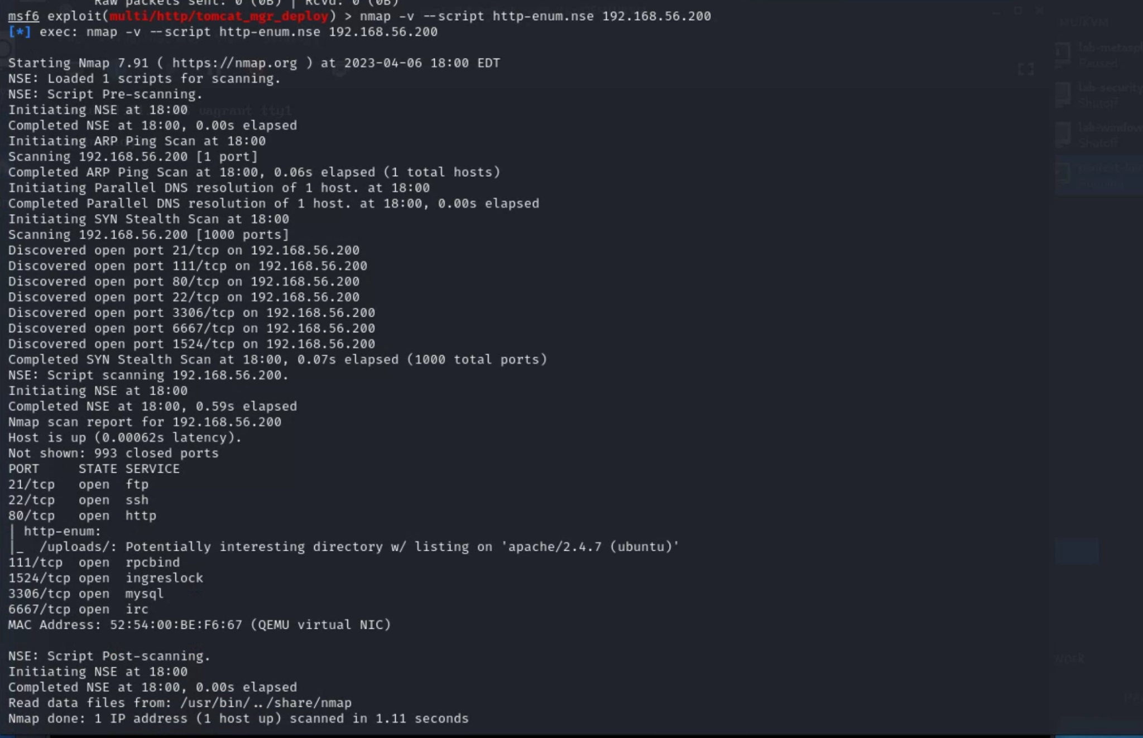

**7.2**

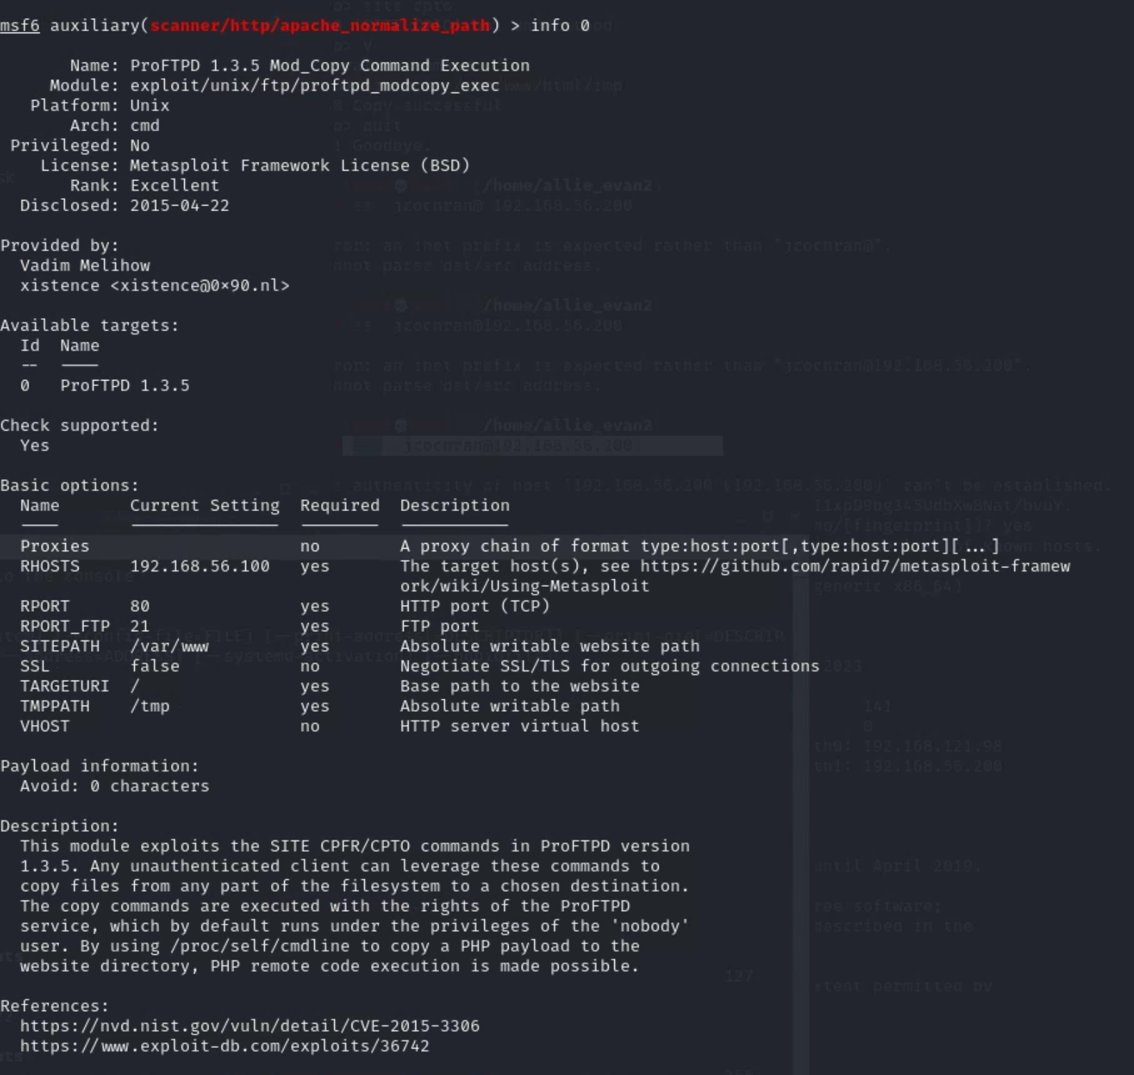

**7.3**

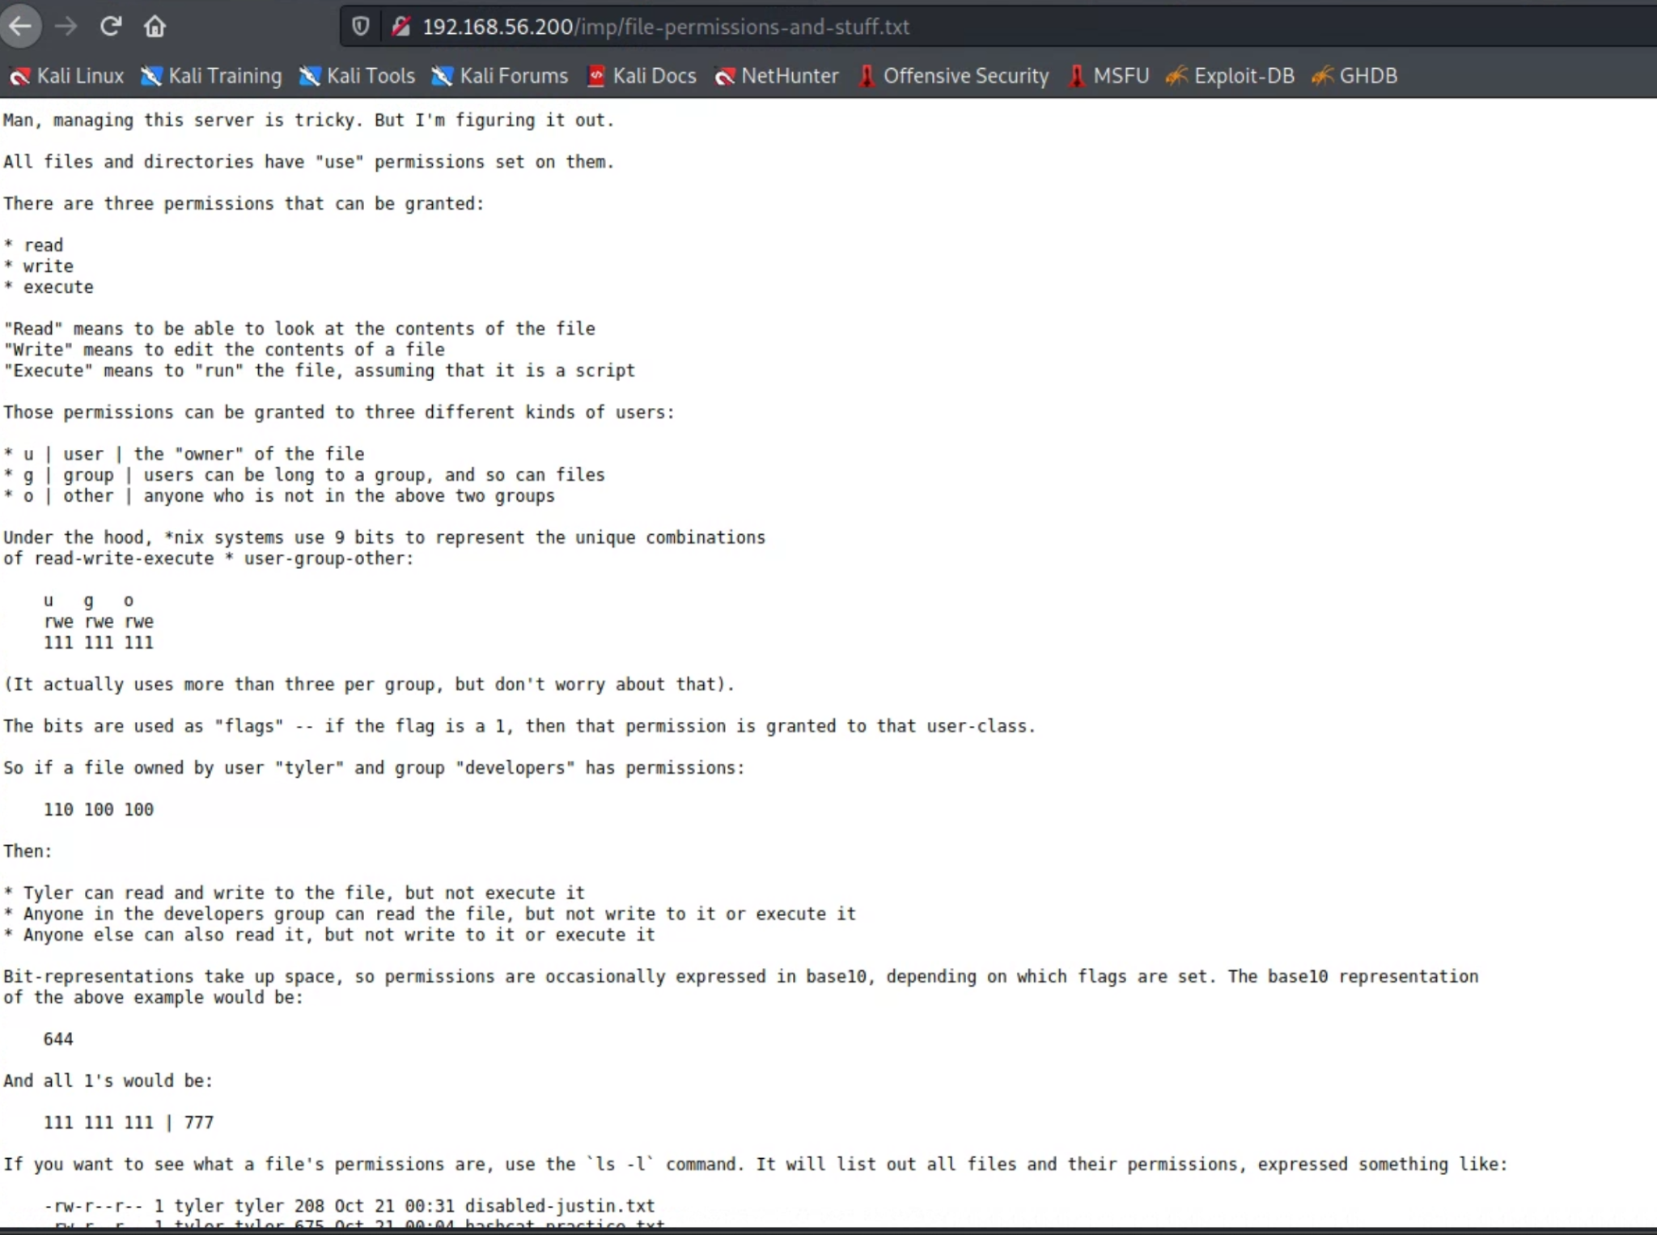

**7.4**

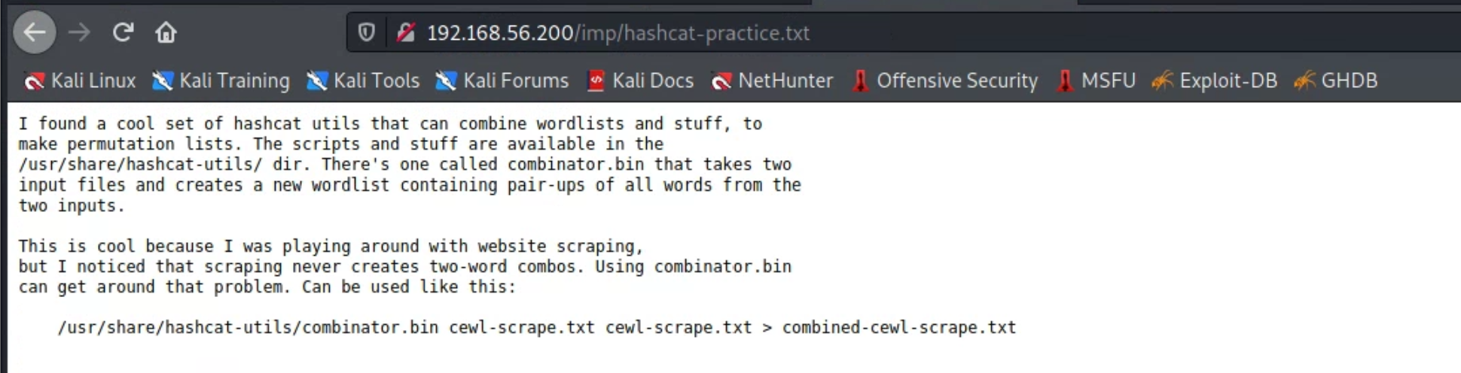

**7.5**

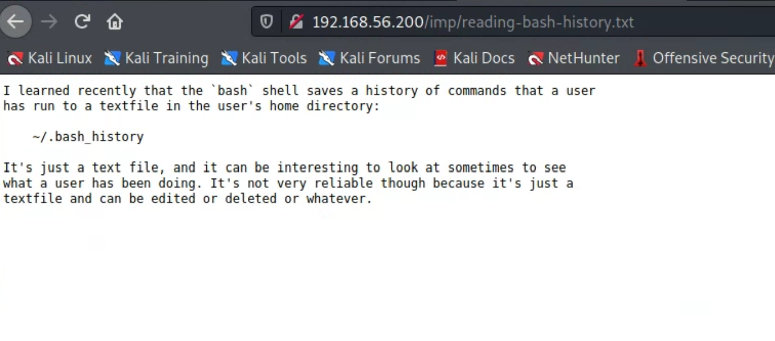

**7.6**

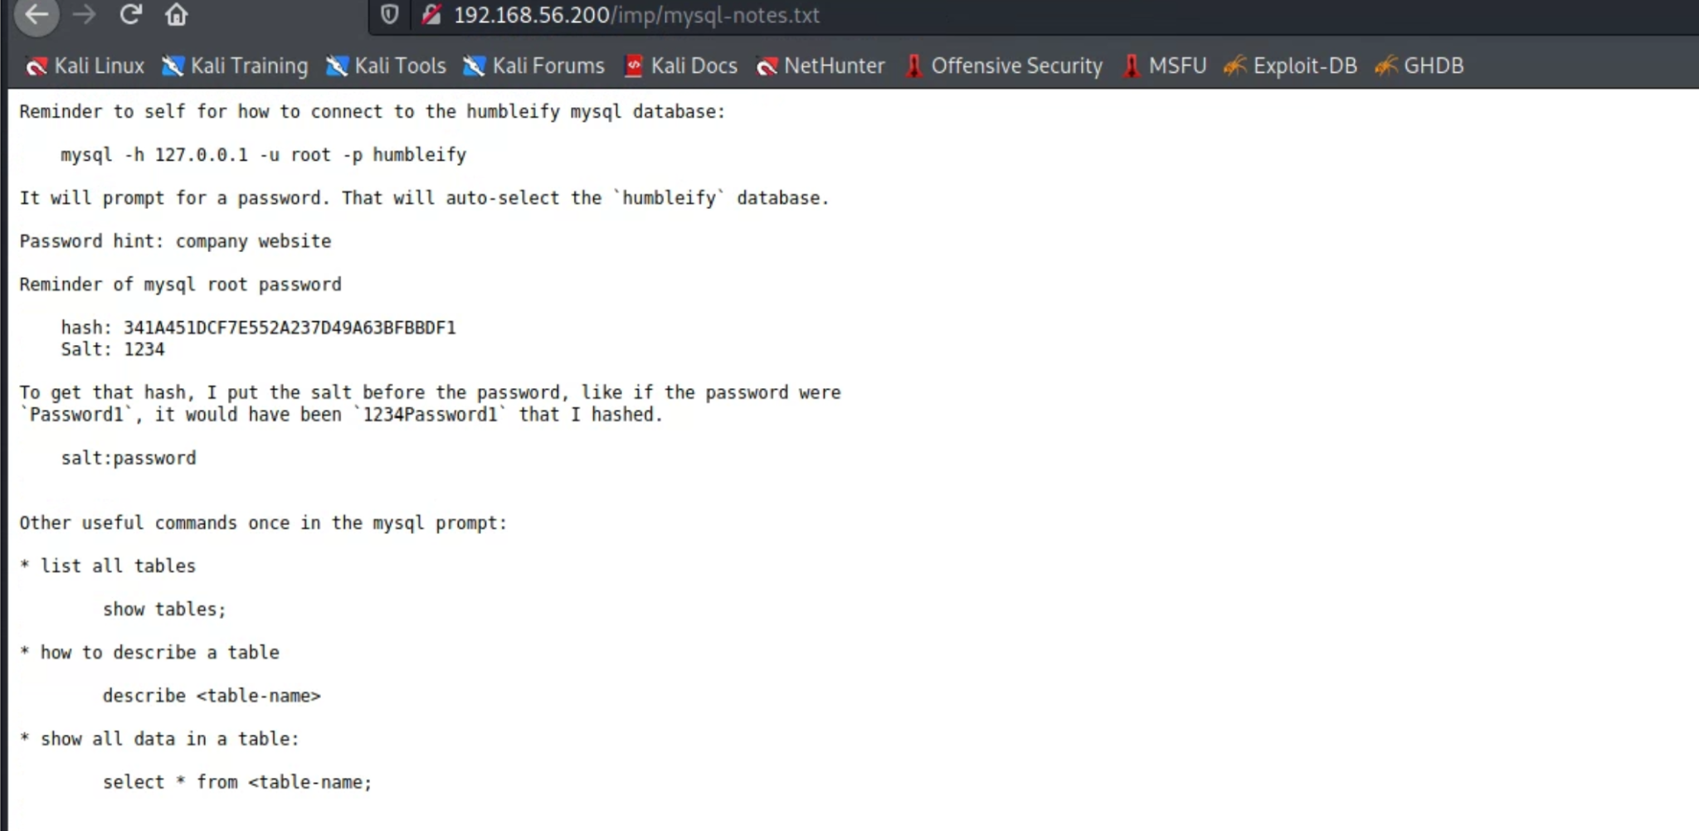

**7.7**

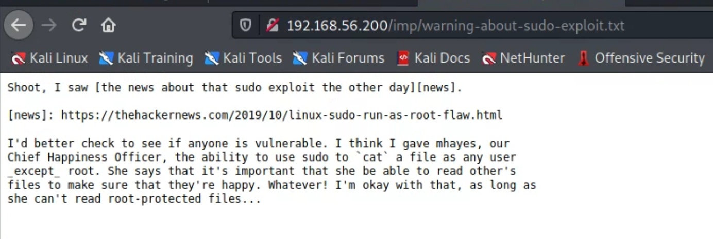

**7.8**

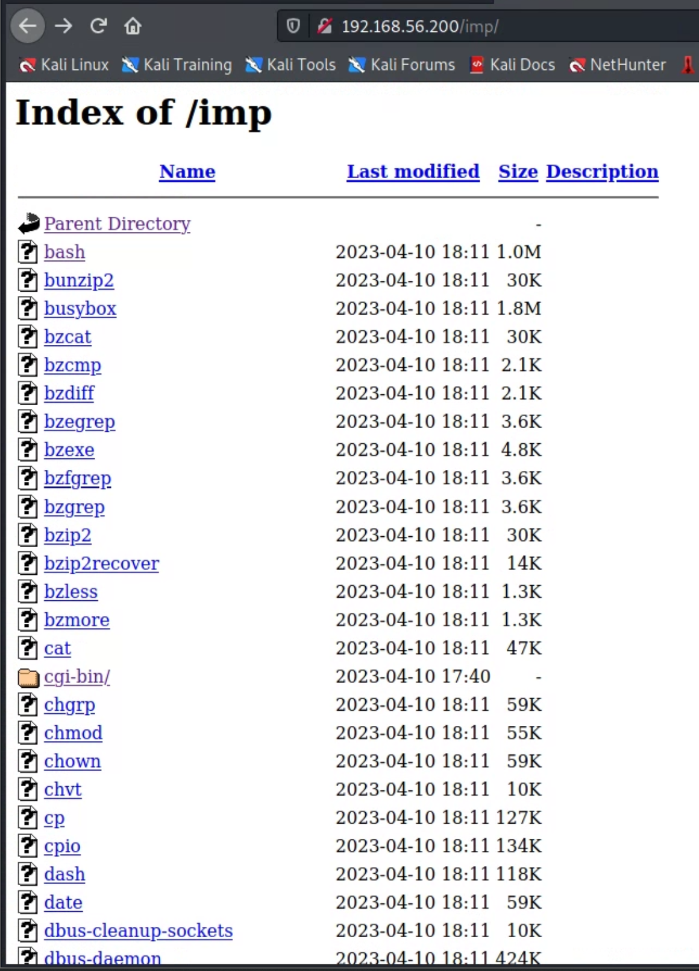

**7.9**

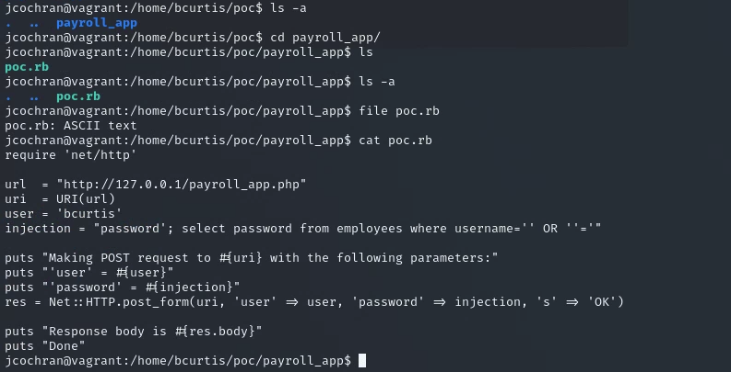

**7.10**

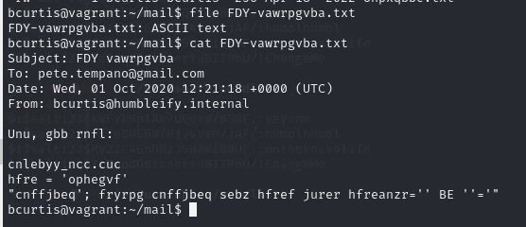

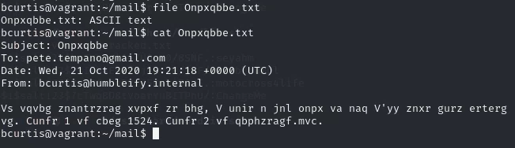

**7.11**

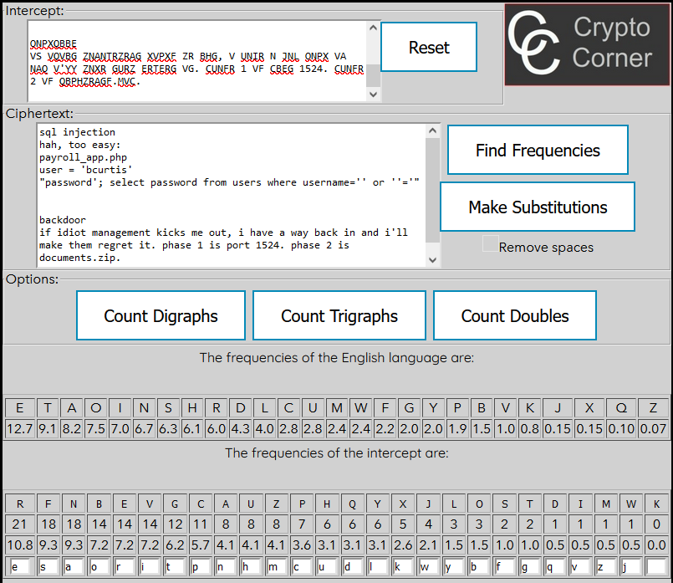

**7.12**

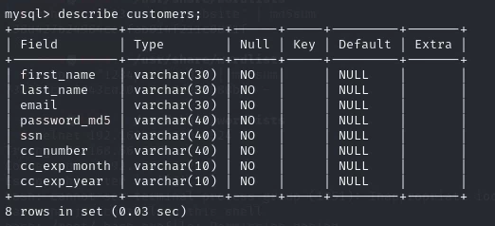

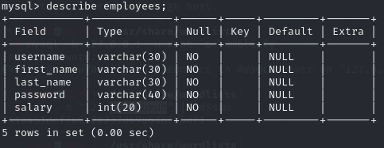

**7.13**



**7.14**

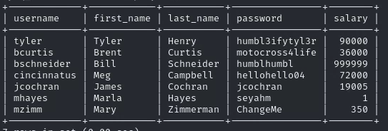

**7.15**

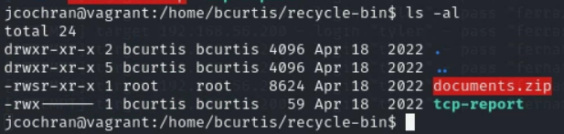



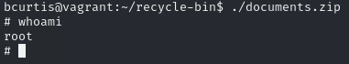

**7.16**

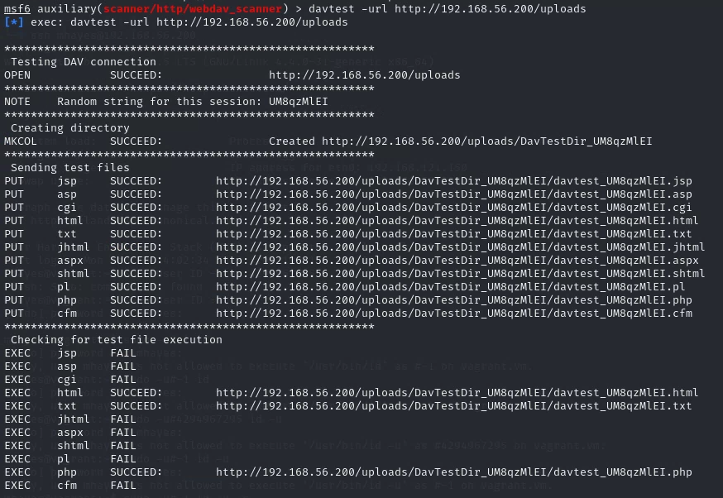

**7.17**



